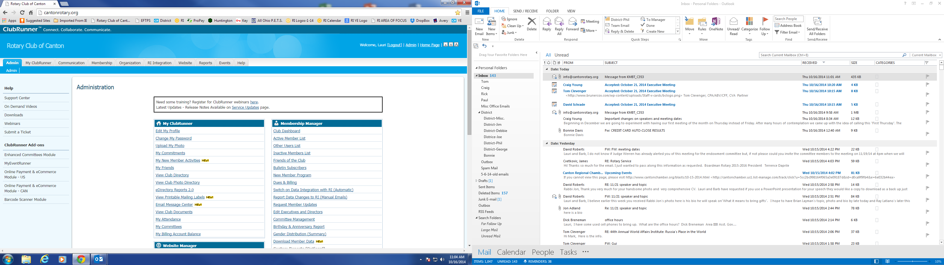

To Print the Club Directory, please follow the steps below:
- Go to our club’s website: www.cantonrotary.org
- Login to our website
- Click on the eDirectory tab
- Under the “Standing Reports “ column, click on the 2014-15 Club Directory tab
- Click on the  or  tab to download the Club Directory
- Click on the “download file” which should appear at the bottom left-hand side of your screen

